Inherited Table

Scripts: create.sql, add_constraint.sql, add_rule_insert.sql, add_rule_update.sql  
  
after creating table, adding constraints and insert rules - insert into table  
insert into inherited.hub (id, name) select i::int, 'test' || (i)::varchar from generate_series(1, 1000000) as g(i);

data distribution:   
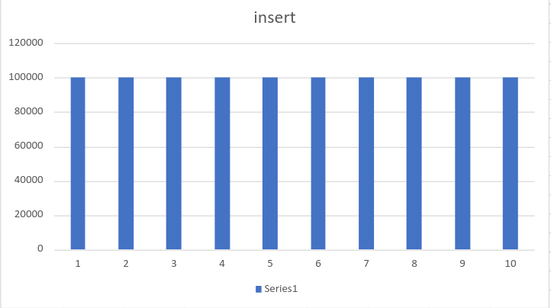  
  
then add update rule and update  
update inherited.hub set name = name || 'new';

data distribution:

